# 1) Write Steps to create projects and assign rights

## Select Kanban or scrum or bug tracking

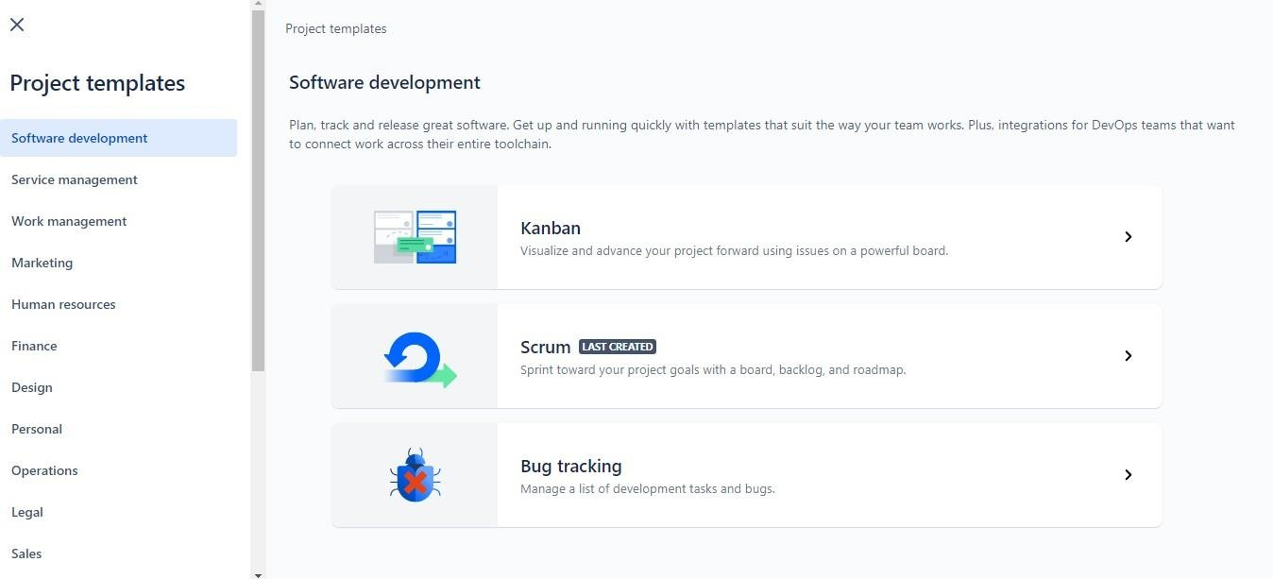

1. Select scrum

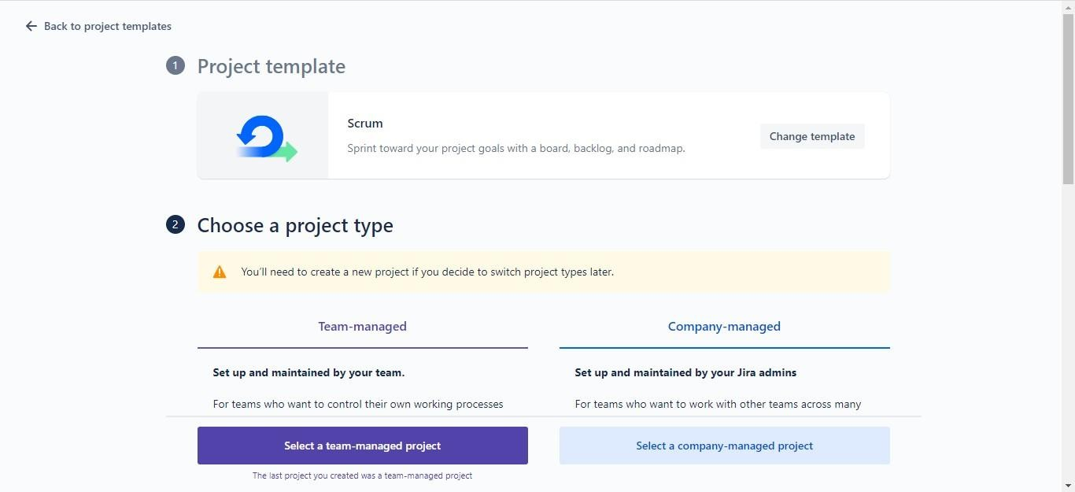

## Give access rights

1. Give project name

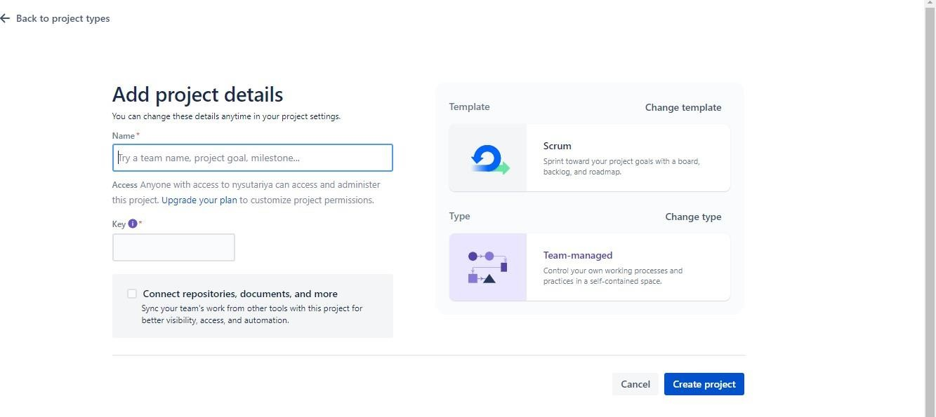

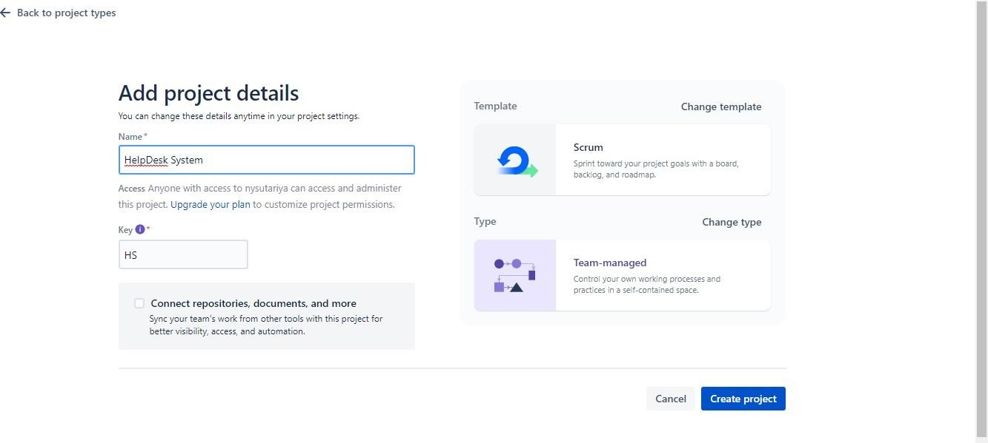

# Which Functionality are provided by Jira

* 1. **Scrum**

# Kanban

* 1. **Bug Tracking**

# Scrum

The Scrum template helps teams work together using sprints to break down large, complex projects into bite-sized pieces of value. Encourage your team to learn through incremental delivery, self-organize while working on a problem, and regularly reflect on their wins and losses to continuously improve.

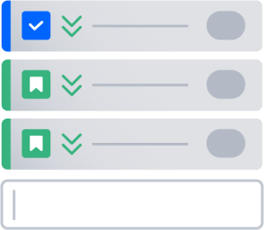

**Plan upcoming work in a backlog**

Prioritize and plan your team's work on the backlog. Break down work from your project roadmap, and order work items so your team knows what to deliver first.

Learn more about the backlog

### Organize cycles of work into sprints

Sprints are short, time-boxed periods when a team collaborates to complete a set amount of customer value. Use sprints to drive incremental delivery, allow your team to ship high- quality work and deliver value faster.

Learn more about sprints

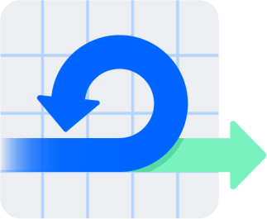

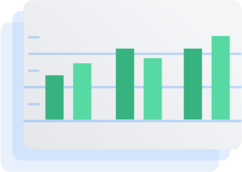

### Understand your team’s velocity

Improve predictability on planning and delivery with out-of-the-box reports, including the sprint report and velocity chart. Empower your team to understand their capacity and iterate on their processes.

Learn more about agile metrics

##### Kanban

kanban (the Japanese word for "visual signal") is all about helping teams visualize their work, limit work currently in progress, and maximize efficiency. Use the Kanban template to increase planning flexibility, reduce bottlenecks and promote transparency throughout the development cycle.



**Track work using a simple board**

Work items are represented visually on your kanban board, allowing teams to track the status of work at any time. The columns on your board represent each step in your team’s workflow, from to-do to done. Learn more about kanban boards

#### Use the board to limit work in progress

Set the maximum amount of work that can exist in each status with work in progress (WIP) limits. By limiting work in progress, you can improve team focus, and better identify inefficiencies and bottlenecks. Learn more about WIP limits

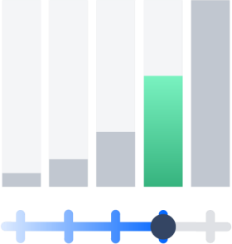

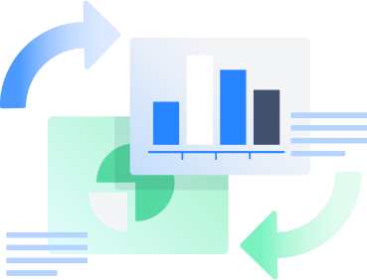

#### Continuously improve with agile reports

One of the key tenets of kanban is optimizing flow for continuous delivery. Agile reports, like the cumulative flow diagram, help ensure your team are consistently delivering maximum value back to your business.

Learn more about agile metrics

##### Bug Tracking

Capture, track and resolve bugs and issues throughout your entire development process. Provide a single source of truth of all your issues and help your team prioritize against their big picture goals, while continually delivering value to your customers.

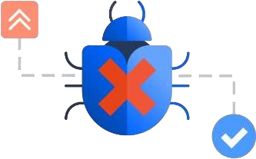

#### Identify and capture bugs

See all your bugs in one place. Once you’ve identified a bug, capture its details by creating an issue from anywhere in your project. Each unique issue type can have its own custom workflow.

#### Assign and prioritize

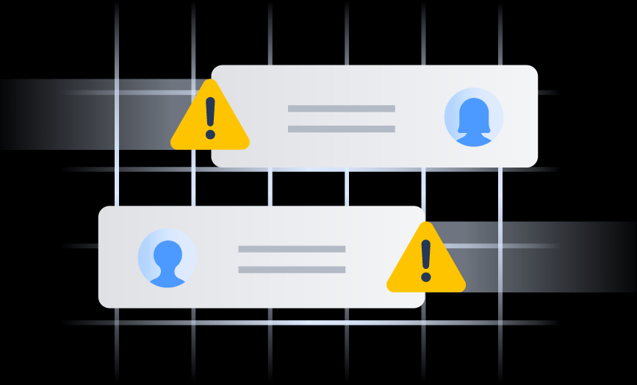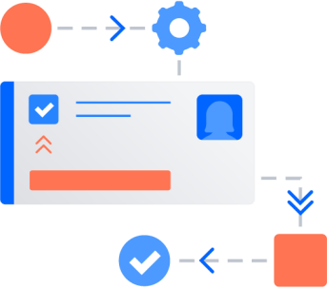Once captured, bugs can be ranked and prioritized based on importance, urgency, and your team’s workload capacity. Assigning bugs is easy and can be accomplished in only a few keystrokes from the issue.

#### Track bugs to done

Stay in the know by tracking bugs and issues through your team’s workflow. Transitioning issues will trigger notifications, automatically informing the next reviewer

# How many Different issues are available in jira.

|  |  |  |  |
| --- | --- | --- | --- |
| **Issue Type** | **Atlassian’s Definition** | **Rachel’s Notes** | **Example Issue Summary (Title)** |
| **Task** | Task that needs to be done | This is your generic “catch all” type. Use it for any type of work not represented by the other available types.  Tip: Creating specifically named tasks (Ex: Security Task, Marketing Task, etc.) is not recommended. | Bake a cake |
| **Sub- task** | Smaller task within a larger piece of work | The smallest piece of work required to complete a larger piece of work. Often used to assign parts of a larger task to different team members. | Mix cake ingredients |
| **Epic** | Large piece of work that encompasses many issues | A term from “Agile” methodology but useful to any type of team, regardless of methodology.  Tip: Link other issues to the Epic they support. | Make deserts for bake sale |
| **Story** | Functionality request expressed from the perspective of the user | AKA: “User Story” or other form of development request. Often used by software development teams to encompass requirements, features, or  enhancements. Sometimes written in the format: As a *<type of user>*, I  want *<some goal>* so that *<some reason>*. | As a bake sale attendee, I would like to eat brownies because I’m allergic to cake OR  Make brownies for bake sale |
| **Bug** | Problem that impairs product or service functionality | Often used to track problems, errors, omissions, defects, or “things to fix”. | Cake is burnt |

1. **Write a steps to create sprint and Assign issue and people to task.**

## click to create sprint

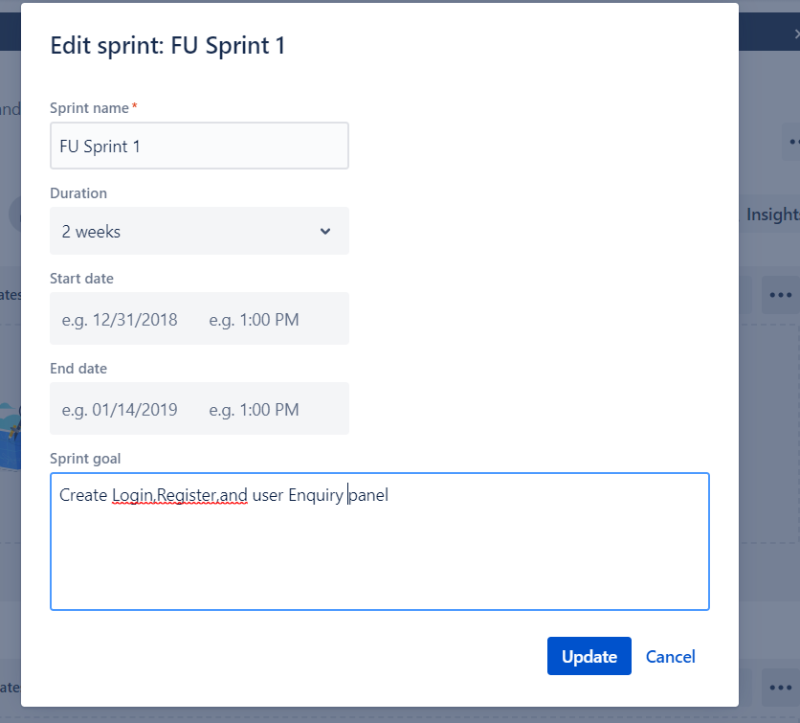

1. Add Epic

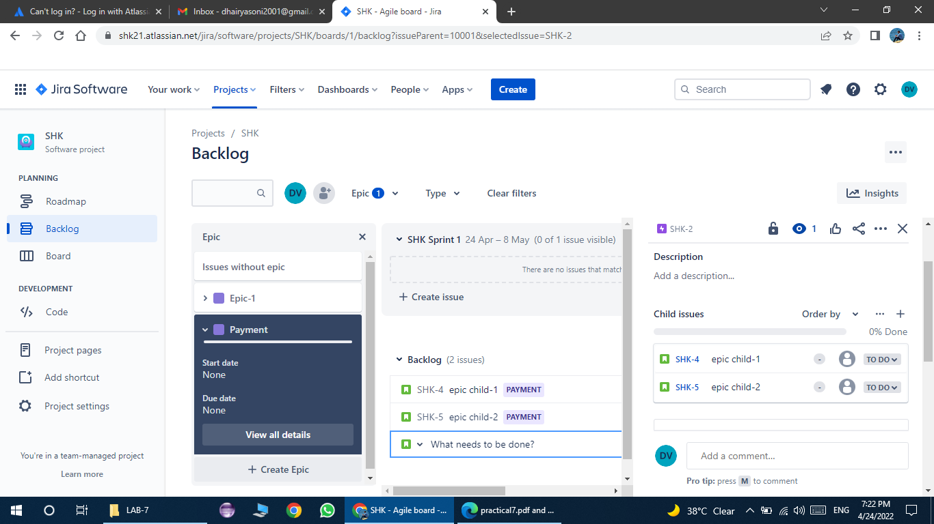

Here I assign Registration Epic and Registration form as story and Terms And Condition page as Task.

Here we can assign people by this way

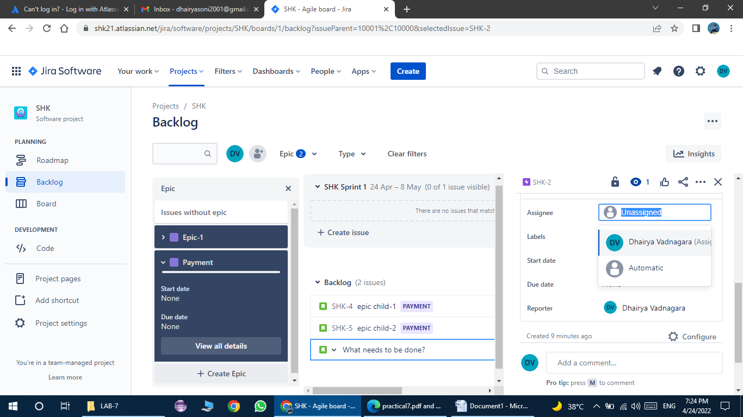

# 5) Write down about epic and story

1. **Epic**

An epic is **a large body of work that can be broken down into a number of smaller stories,or sometimes called “Issues” in Jira**. Epics often encompass multiple teams, on multiple projects, and can even be tracked on multiple boards. Epics are almost always delivered over aset of sprints.

A term from “Agile” methodology but useful to any type of team, regardless of methodology. Tip: Link other issues to the Epic they support.

Example Make deserts for bake sale

# Story

Functionality request expressed from the perspective of the user

AKA: “User Story” or other form of development request. Often used by software development teams to encompass requirements, features, or enhancements. Sometimes written in the format: As a *<type of user>*, I want

*<some goal>* so that *<some reason>*.

Example

As a bake sale attendee, I would like to eat brownies because I’m allergic to cake OR Make brownies for bake sale